Task 1
Write a procedure (1 page maximum) for filling up a car with gas.
Filling up the tank of the car at a self-service gas station is not a fast way however, it can save a few dollars in the process. Following are the steps on how to operate the pump and fill up the gas pump:
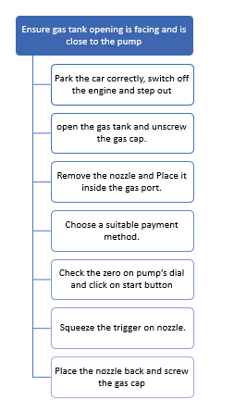
- Step- 1: Ensure the vehicle’s gas tank opening is facing and is close to the pump.
- Step-2: Once the car is parked correctly, switch of the engine and get out of the car.
Please Note: Do not smoke or operate your mobile phone once at the gas station for safety purposes.
- Step-3: Depending on the model of the car, open the gas tank and unscrew the gas cap
- Step-4: Remove the nozzle before selecting the gas type. Place it inside the gas port and make sure it fits the nozzle in the gas port.
- Step-5 Choose a suitable payment method before operating the pump (pay by credit, debit to pay at the pump or you may pay at the counter). You may typically have three types of gasoline: Regular, Mid-Grade and Premium. Regular gasoline works just fine, unless you have a high-performance car. For a diesel engine, look for a diesel pump usually with a green handle.
- Step-6: Check the zero on pump’s dial and click on start button to turn on the machine.
- Step-7: Squeeze the trigger on nozzle as you fill the fuel. As the tank fills, you may notice the zero changing. The fuel will stop automatically once the zero enters the desired amount.
- Step-8: Finally, place the nozzle back and turn the gas cap till you hear a click sound of the cap.
Please Note: If you choose to pay the amount at the counter, you may go ahead and pay for the gas inside the store.

